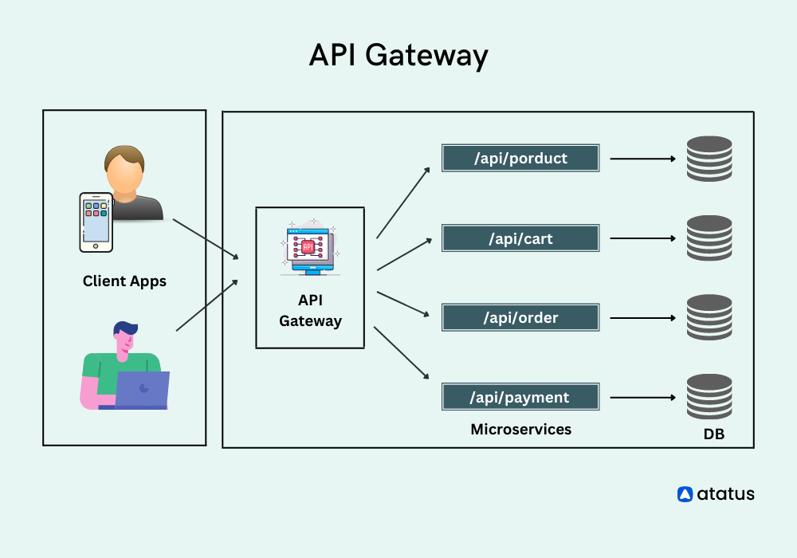

**Define API Gateway Routes**

You can configure the API Gateway in two ways

1. YAML Configuration (application.yml/application properties)

@Configuration  
public class GatewayConfig {  
  
 @Bean  
 public RouteLocator gatewayRoutes(RouteLocatorBuilder builder) {  
 return builder.routes()  
 .route("product-service", r -> r.path("/product/**")  
 .uri("http://localhost:8081"))  
 .route("order-service", r -> r.path("/orders/**")  
 .uri("http://localhost:8082"))  
 .build();  
 }  
  
}

@SpringBootApplication  
//@EnableDiscoveryClient  
public class ApiGatewayServiceApplication {  
  
 public static void main(String[] args) {  
 SpringApplication.*run*(ApiGatewayServiceApplication.class, args);  
 }  
  
}

1. Java-Based Configuration (GatewayConfig.java)

spring.application.name=api-gateway  
  
server.port=8000  
  
#eureka configuration  
eureka.client.service.url.defaultZone=http://localhost:8761/eureka/  
spring.cloud.gateway.discovery.locator.enabled=false  
spring.cloud.netflix.eureka.discovery.enabled=true  
  
#define static routes for product service application  
spring.cloud.gateway.routes[0].id=product-service  
spring.cloud.gateway.routes[0].uri=lb://PRODUCT-SERVICE  
spring.cloud.gateway.routes[0].predicates[0]=Path=/product/**  
  
#define static routes for order service application  
spring.cloud.gateway.routes[1].id=order-service  
spring.cloud.gateway.routes[1].uri=lb://ORDER-SERVICE  
spring.cloud.gateway.routes[1].predicates[0]=Path=/orders/**

API GATEWAY WITH FEIGN CLIENT

Example

1.student service

2.course service

3.faculty service

4.Api gateway service

Student Service

Structure

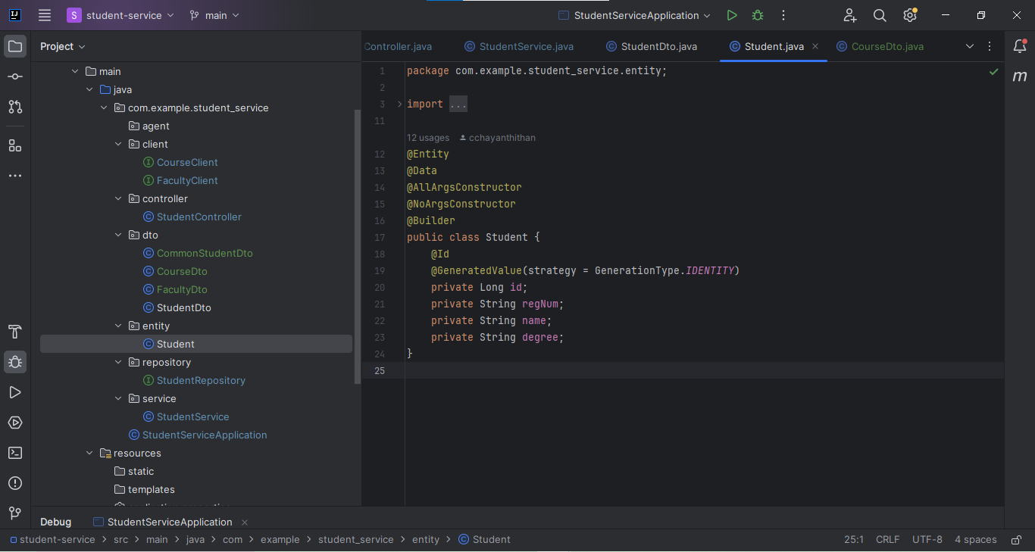

Student Service main method

package com.example.student_service;  
  
import org.springframework.boot.SpringApplication;  
import org.springframework.boot.autoconfigure.SpringBootApplication;  
import org.springframework.cloud.openfeign.EnableFeignClients;  
  
@SpringBootApplication  
@EnableFeignClients  
public class StudentServiceApplication {  
  
 public static void main(String[] args) {  
 SpringApplication.*run*(StudentServiceApplication.class, args);  
 }  
  
}

client

faculty client

package com.example.student_service.client;  
  
import com.example.student_service.dto.FacultyDto;  
import org.springframework.cloud.openfeign.FeignClient;  
import org.springframework.web.bind.annotation.GetMapping;  
import org.springframework.web.bind.annotation.PathVariable;  
import org.springframework.web.bind.annotation.PostMapping;  
import org.springframework.web.bind.annotation.RequestBody;  
  
import java.util.List;  
  
@FeignClient(name = "faculty-client",url = "http://localhost:8083")  
public interface FacultyClient {  
 @GetMapping("/faculty")  
 public List<FacultyDto> getAllFaculties();  
  
 @GetMapping("faculty/id/{id}")  
 public FacultyDto getFacultyById(@PathVariable Long id);  
  
 @PostMapping("/faculty")  
 public FacultyDto addFacultyDetails(@RequestBody FacultyDto facultyDto);  
  
 @GetMapping("faculty/name/{name}")  
 public FacultyDto getFacultyByName(@PathVariable String name);  
}

course client

package com.example.student_service.client;  
  
import com.example.student_service.dto.CourseDto;  
import org.springframework.cloud.openfeign.FeignClient;  
import org.springframework.web.bind.annotation.GetMapping;  
import org.springframework.web.bind.annotation.PathVariable;  
import org.springframework.web.bind.annotation.PostMapping;  
import org.springframework.web.bind.annotation.RequestBody;  
  
import java.util.List;  
  
@FeignClient(name = "course-service",url = "http://localhost:8081")  
public interface CourseClient {  
 @GetMapping("/course")  
 public List<CourseDto> getAllCourse();  
  
 @PostMapping("/course")  
 public CourseDto addCourse(@RequestBody CourseDto courseDto);  
  
 @GetMapping("course/id/{id}")  
 public CourseDto getCourseById(@PathVariable Long id);  
 @GetMapping("course/name/{name}")  
 public CourseDto getCourseByName(@PathVariable String name);  
}

Api Gateway

Structure

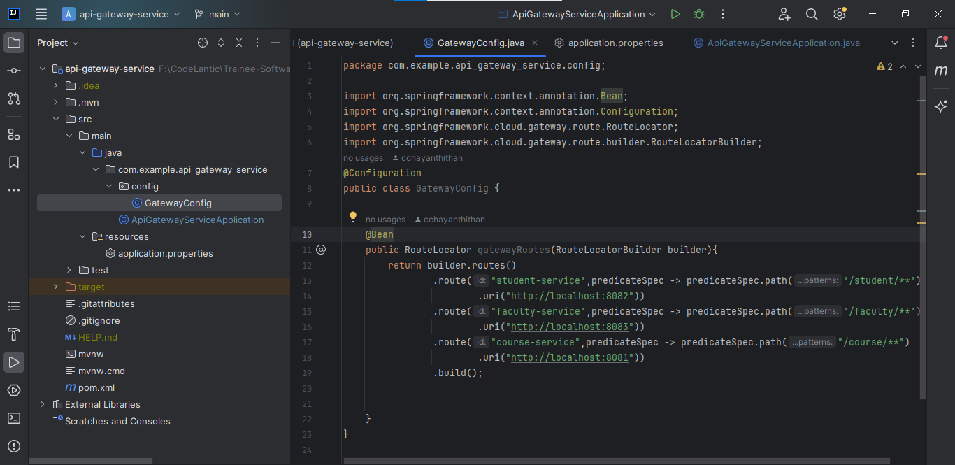

Config

GatewayConfig

package com.example.api_gateway_service.config;  
  
import org.springframework.context.annotation.Bean;  
import org.springframework.context.annotation.Configuration;  
import org.springframework.cloud.gateway.route.RouteLocator;  
import org.springframework.cloud.gateway.route.builder.RouteLocatorBuilder;  
@Configuration  
public class GatewayConfig {  
  
 @Bean  
 public RouteLocator gatewayRoutes(RouteLocatorBuilder builder){  
 return builder.routes()  
 .route("student-service",predicateSpec -> predicateSpec.path("/student/**")  
 .uri("http://localhost:8082"))  
 .route("faculty-service",predicateSpec -> predicateSpec.path("/faculty/**")  
 .uri("http://localhost:8083"))  
 .route("course-service",predicateSpec -> predicateSpec.path("/course/**")  
 .uri("http://localhost:8081"))  
 .build();  
  
  
 }  
}